Chapter 1
Introduction
The objective and scope of this project is to help every computer user to get familiar with digital data and different types of line coding schemes which is used to transmit data in electric signals. As already mentioned above that this project helps users to display digital data in graphical manner.
The software is more efficient because user can easily track their total record after completing their operation. In this software the facilities are can be stated as,
- User can read their track record from start to end of the program.
- User can freely enter the data which they want.
- At the time of graphical representation user can get valuable information about current line coding technique.
- Any kind of user can be familiar with line coding scheme using this software
- User can access the log files to track the use of software.

Conversion of digital data to digital signal is in form of bits.
Line coding: -
Line coding is the process of converting digital data to digital signals. It converts a sequence of waves to a digital signal at the sender. Digital data are encoded into digital signal and at the receiver digital data are recreated by decoding the digital signal.

Different line coding schemes are:
1) Unipolar
i) NRZ
2) Polar
- NRZ
- RZ
iii) Biphase
3) Bipolar
i) Ami
ii) Pseudoternary

  - Objective:
- In “Line coding scheme”, user can easily understand the coding techniques used to represent digital data. And how digital signal transmission is done.
- It will help to user to generate binary code of data entered by user.

1.2 Problem Statement:
To develop software which will help the user to understand the how line coding schemes used to generate digital signal.

Chapter 2
SYSTEM ARCHITECTURE

2.1 SYSTEM DESIGN:
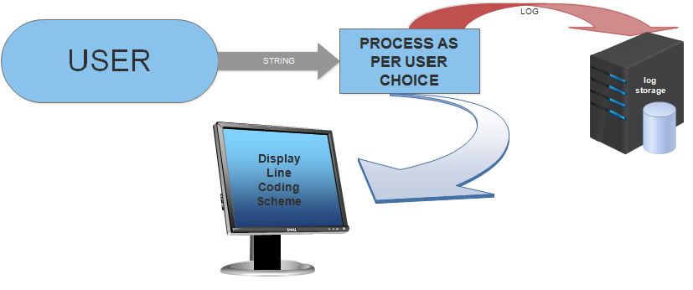

In this system user interact with no. of characters entered by user to performing various types of line coding scheme operation. On that basis user can get desired output from software user can track record using log files. We can exit from the main menu directly.
The different operation performed is as follows:
a) Convert string into binary.
b) Select option from user.
c) Give proper output.
d) Store record into log.
e) Display log file.

2.2 Algorithm:

Step 1: START

Step 2: Get choice from USER
1:Unipolar 2:Polar 3:Manchester 4:AMI
0:Exit

Step 3: If (first run) get string
Else ask to user for use existing string
If (y) Use old string
If (n) get string

Step 4: Convert string to binary
Display output

Step 5: If choice is ‘0’
Exit

Step 6: END

2.3 Flow Chart:
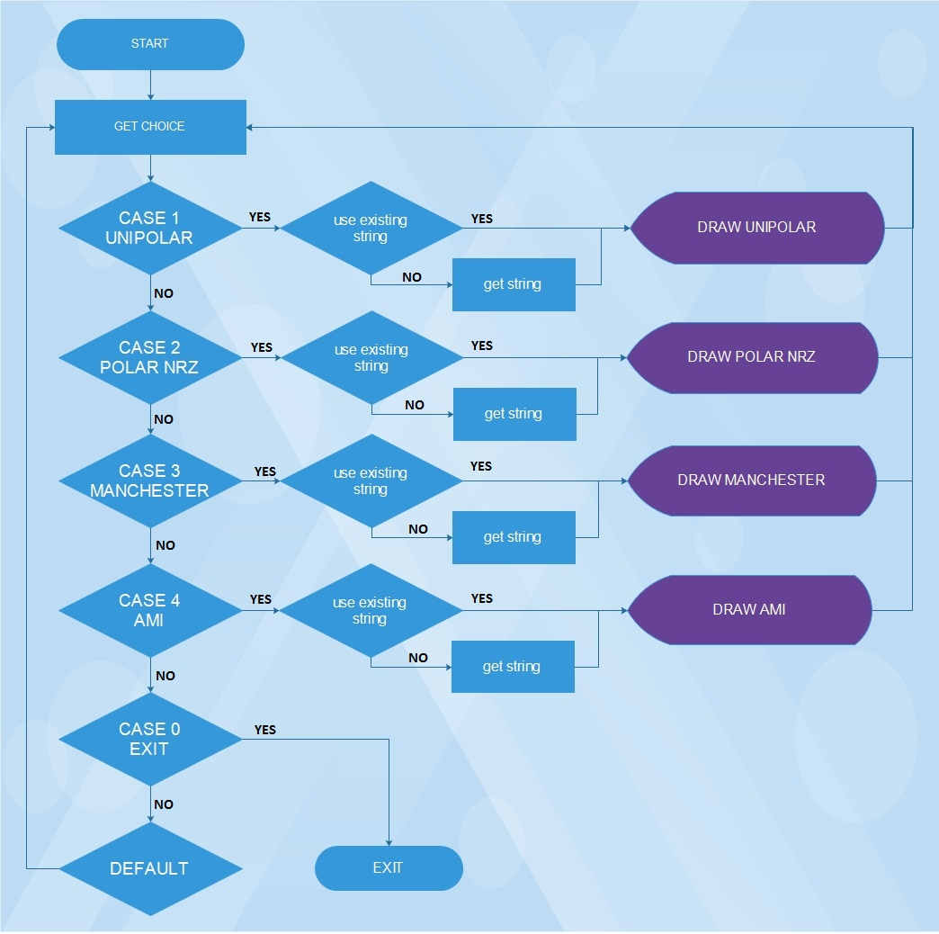

Chapter 3
SYSTEM REQUIREMENT SPECIFICATION

  - Software Requirements:
Operating System: Windows XP / Vista / 7 / 8 / 8.1/ 10, Android (with Turbo c)
Front-end: C, CPP
Back-end: Turbo C++, notepad

  - Hardware Requirements:
The minimum hardware requirement for this project is as follows:
- Intel Pentium Processor (Min. 550 MHz)
- 256 MB RAM
- 40 GB HDD
- Internet facility is not required.

Chapter 4
ADVANTAGES & FUTURE DEVELOPMENT
4.1 Advantages:
- This project will help in learning different types of line coding schemes.

- It will graphically display how the signal will generate.

- User can see the log file for tracking the use of the project

4.2 Future Development:
It is not possible to develop a system that fulfill all the requirement of the user. Users requirement are keep changing as the system is being used.
Some of the future enhancement that can be done to this system are:
- In future actual transmission of digital data can be seen graphically on monitor.
- Provide some more features like reading digital signal from scanning graphical line coding images.

Chapter 5
SCREENSHOTS
- Welcome
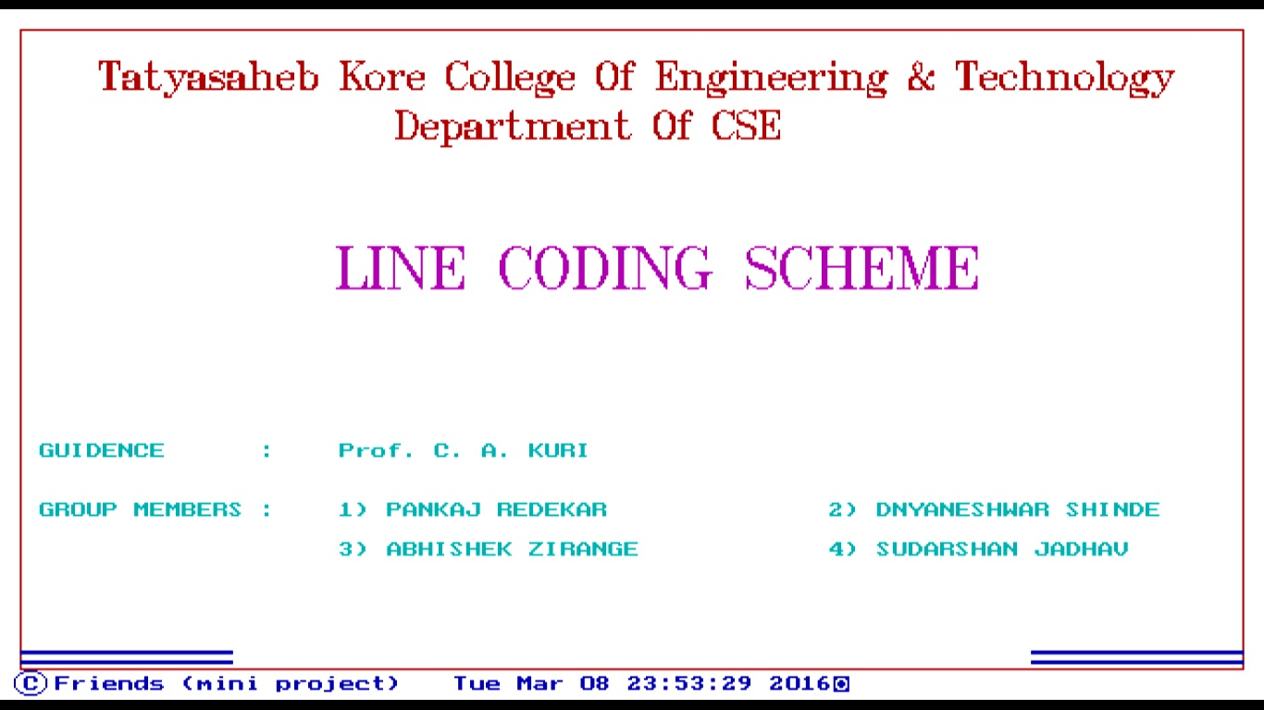
- Main Menu
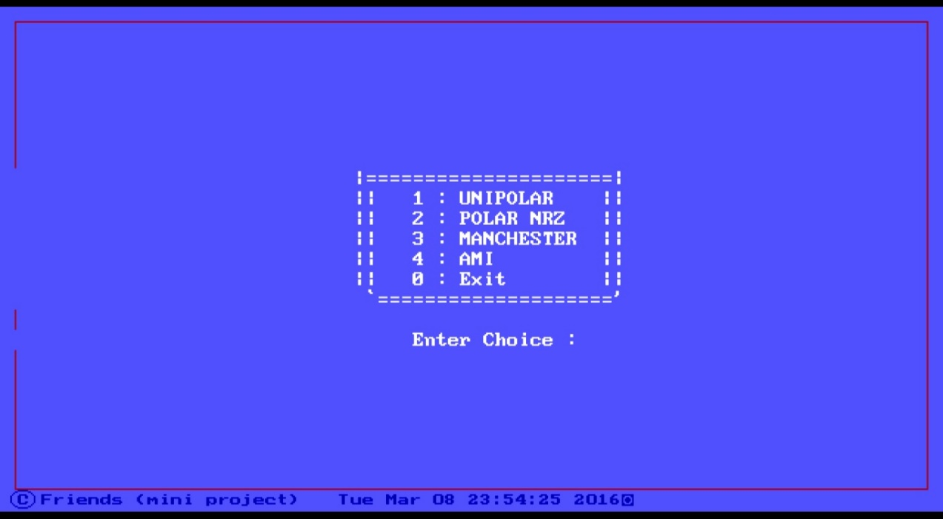
- Get String
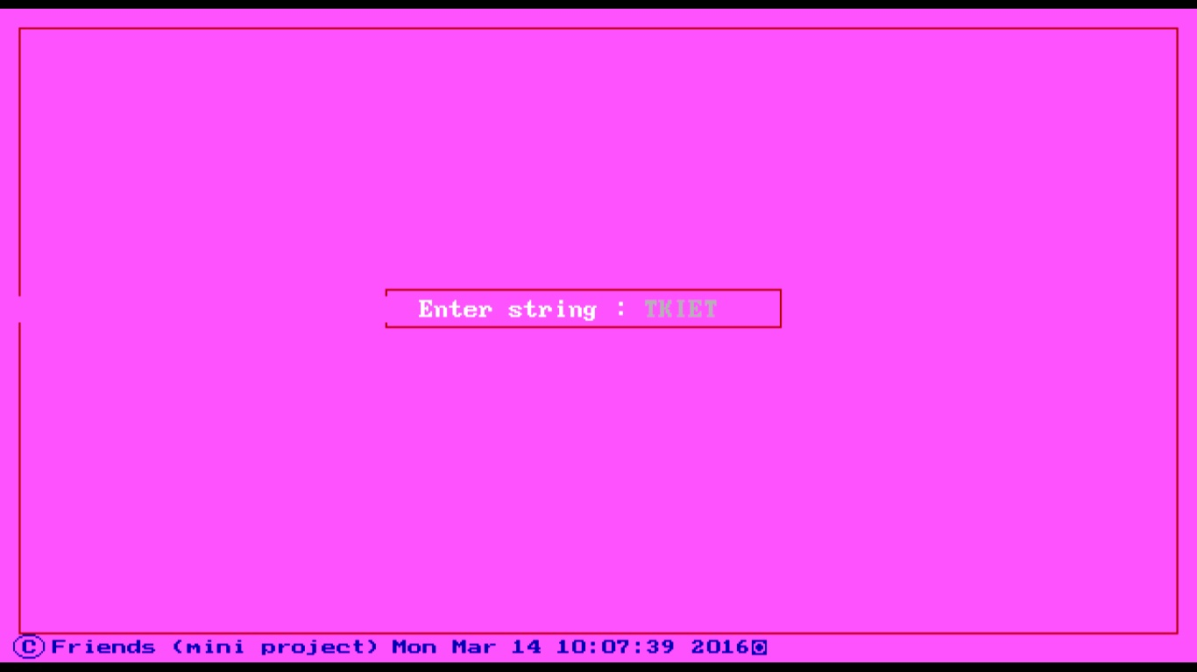
- Unipolar
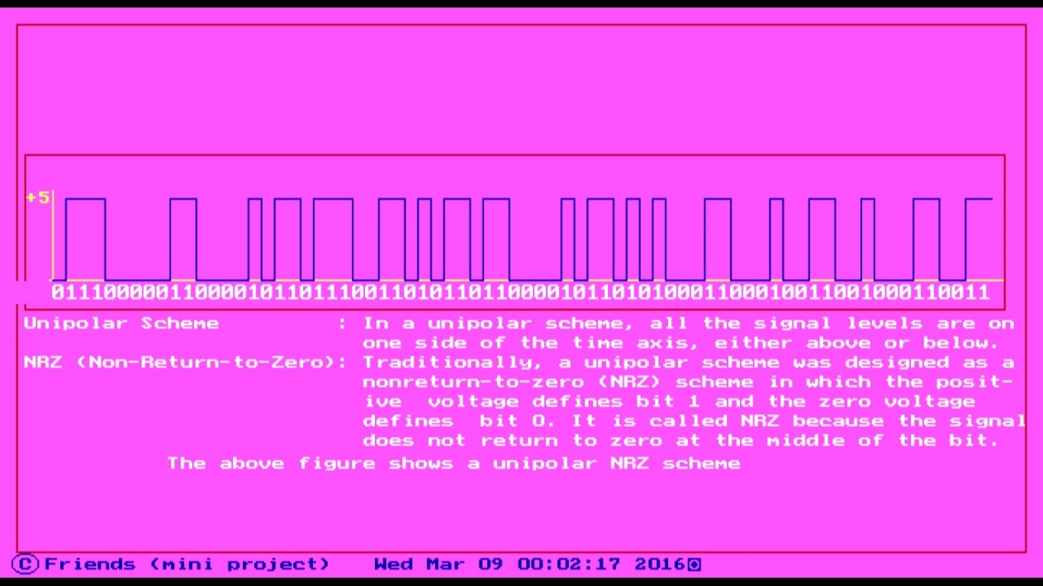

- Check_string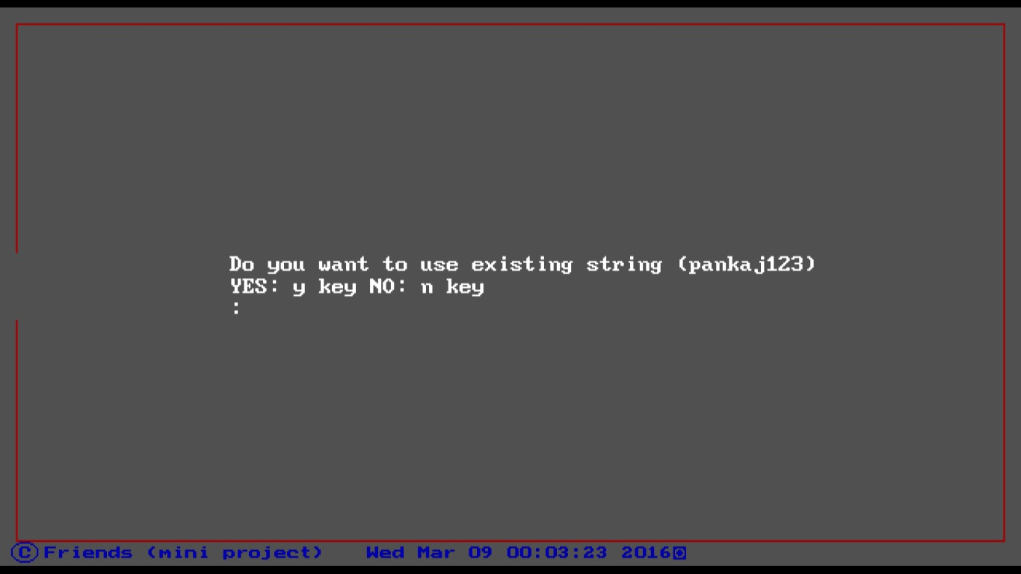
- Polar NRZ 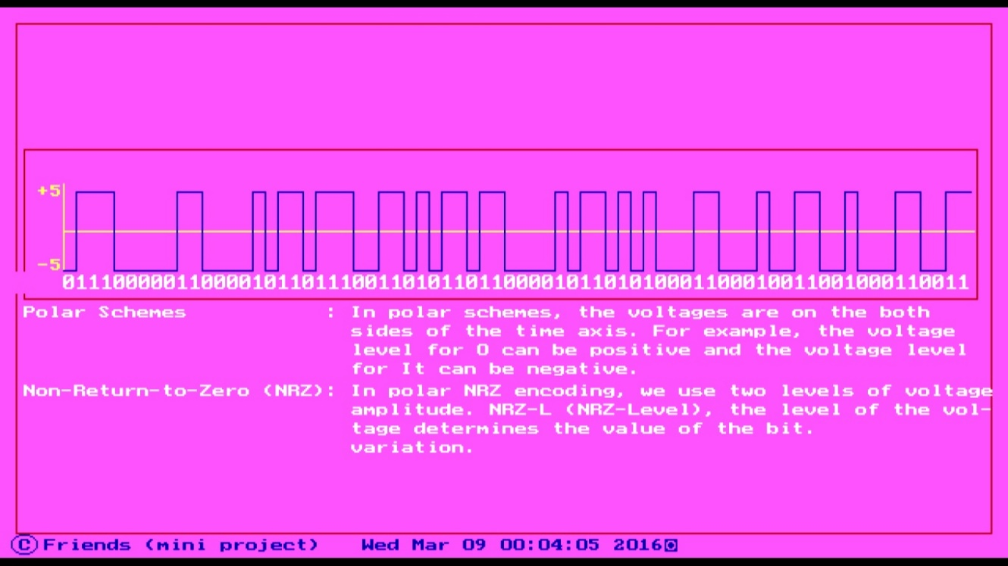
- Manchester 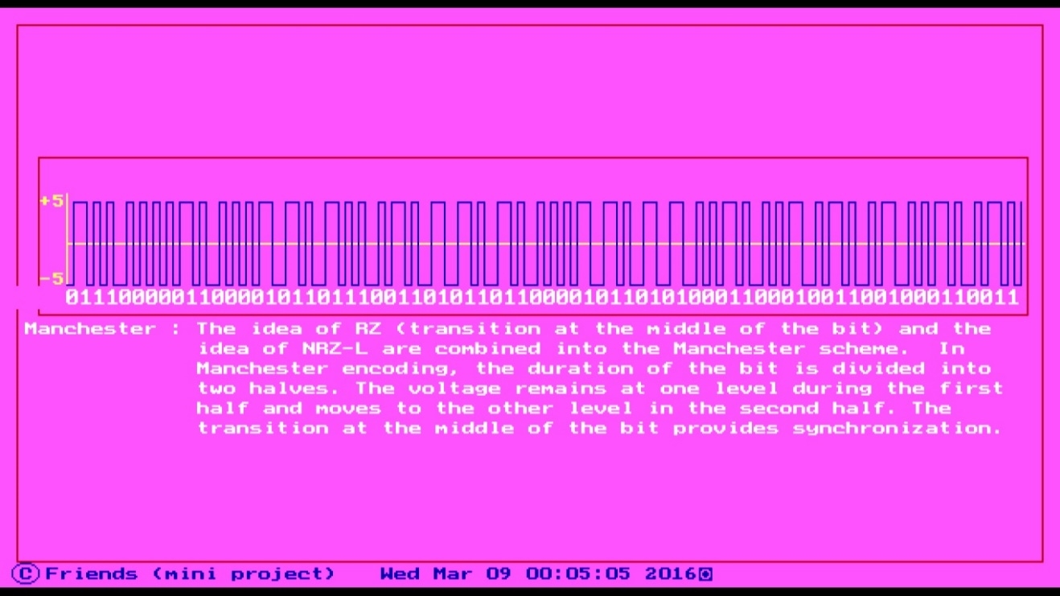
- AMI 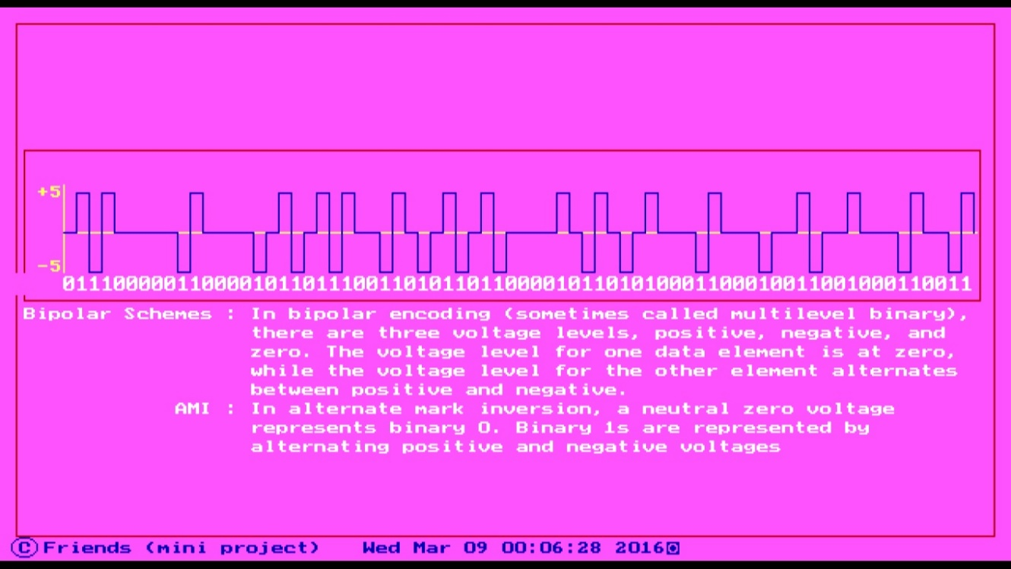

- End (Thank You)
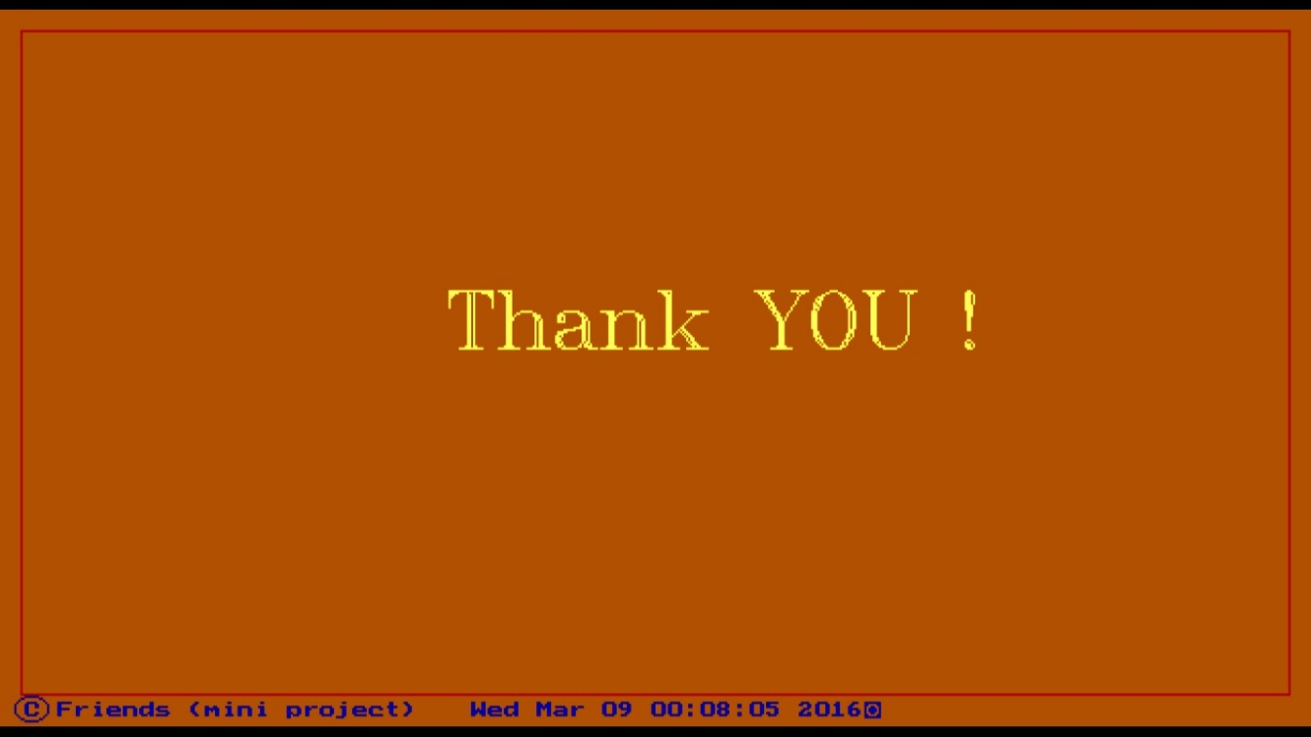
- Log File
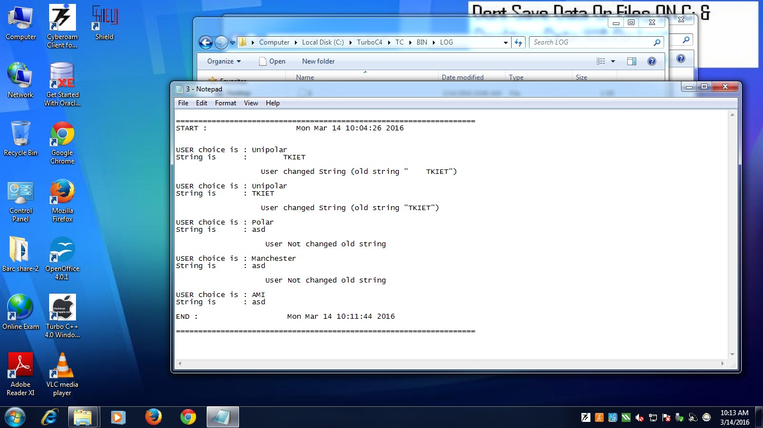
Chapter 6
CONCLUSION:
This project is a desktop based system which helps to the user to getting familiar with different types of coding techniques used to represent digital signal.
In a present system it is easy to new user to draw different line codes using this system, see the contents of that present in log folder after completing the process of system. In menu user can get different choice for different line coding techniques. On the basis user choice system will display different line coding technique. At every time of new run of this system will create new file for storing user activity from starting time to the end of the run it will keep all record in file.
Hence, using this system user get familiar with different Line Coding Techniques.

Chapter 7
REFERENCES:

7.1Books:
- Turbo c/c++ help documentation
- The Complete Reference C++ - Herb Schild
- Computer Networks - Andrew S. Tanenbaum

7.2 Links
- http://codetkiet.github.io/line-coding-scheme (Project Site)
- http://github.com/PankajRedekar
- http://github.com/Dnyaneshwarshinde
- http://github.com/abhishekzirange
- http://github.com/jadhavsudarshan

